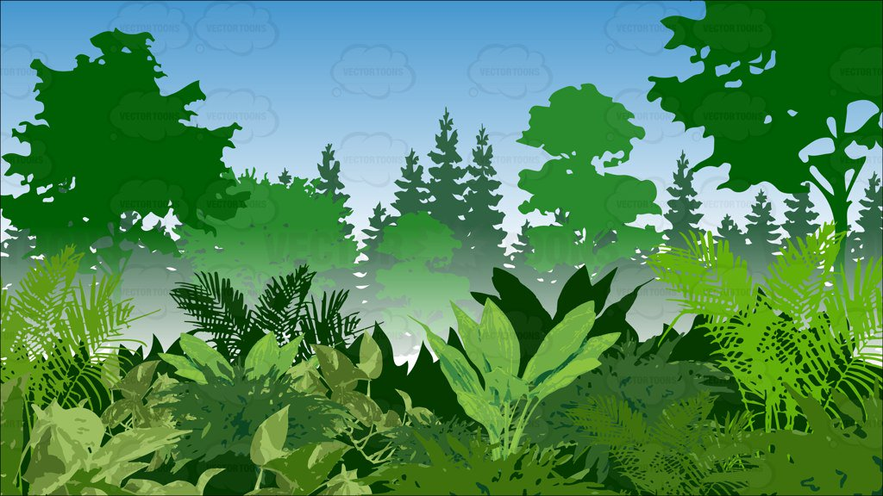



**Whole School Events**

* MONDAY AM- Bouncy assault course Class time table on board
* TUESDAY AM- come in wellies- Treasure hunt on the field (find the golden lady bird) BIG READ PM
* FRIDAY- BONFIRE DAY- we burn our giant mini beast at 2:00pm

16th-20th October 2017

**Outdoor Adventure Week**

**DT**

* Building and evaluating outdoor shelters
* Cooking- survival style- what nutrition do you need to survive? Can you create a survival snack?
* Build a giant mini beast to burn on the bonfire

**Literacy**

* Instructions for any of the thematic activities this week (e.g. Den building, recipes/instructions for food cooked on a fire)
* Writing an adventure story- (genres you might want to copy include, Tin Tin, Indiana Jones – *8 minute clip of opening for Indiana jones and the last crusade is a good video primer- clip ready to play in Outdoor adventure week folder*, Bear Grylls- claws of the crocodile)
* Poetry inspired by outdoors (Wordsworth’s ‘I wondered lonely as a cloud’ is a good example to emulate )

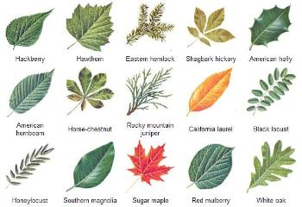

**Big Read** (Tuesday pm)

Negotiate with your partner class

|  |  |
| --- | --- |
| YR | Y3 |
| YR/1 | Y4 |
| Y1/2 | Y5 |
| Y2 | Y6 |

**Music**

* Create instruments from natural scavenged resources
* Be inspired by famous music inspired by the outdoors-
* *Vivaldi the four season*
* *Rimsky-Korsakov- flight of the bumble bee*

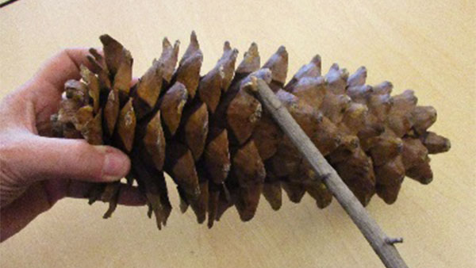

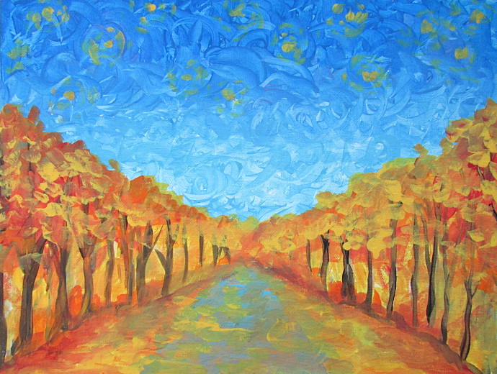

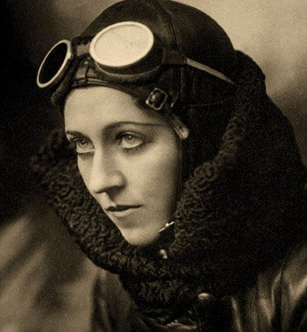

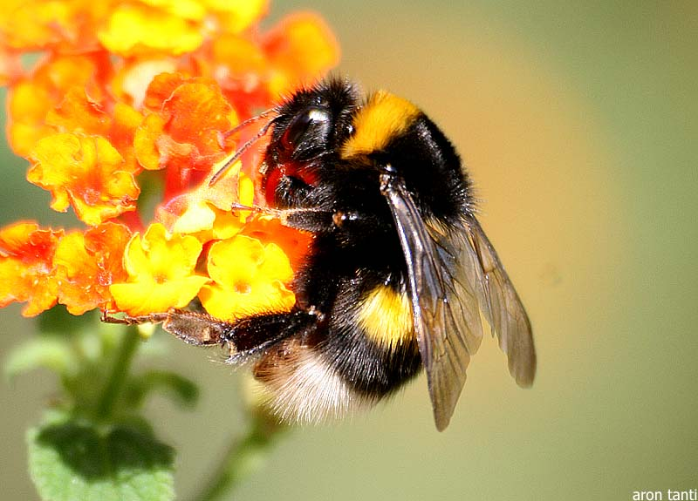

**PE**

The climbing wall and assault course can be used for challenges and competitions

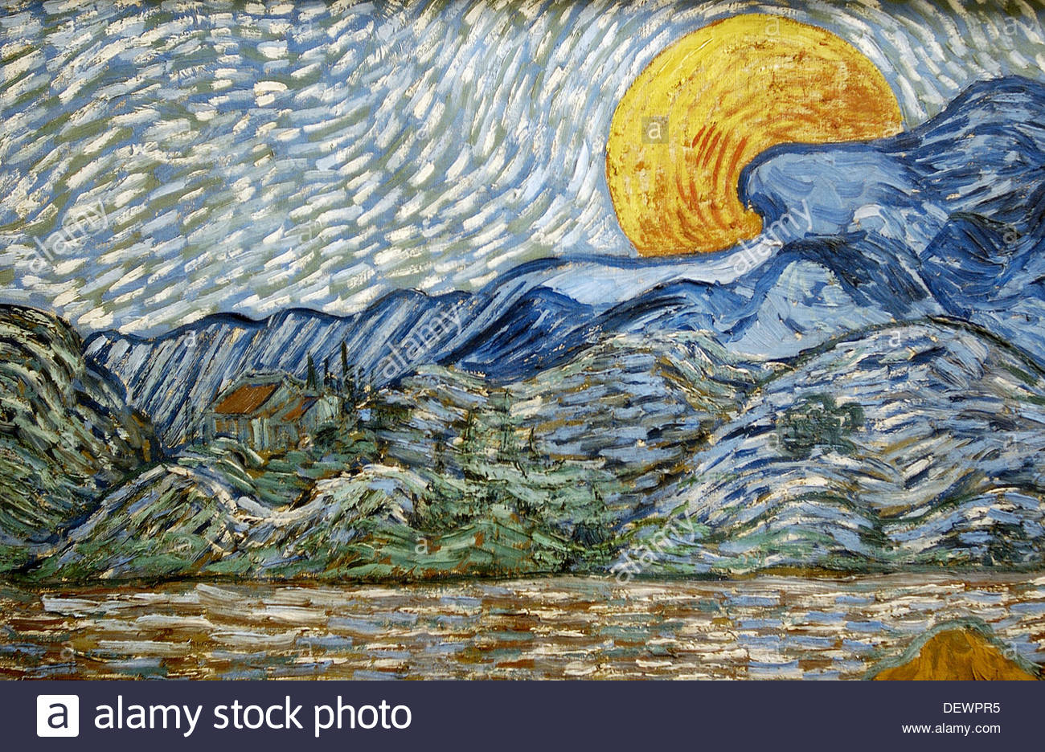

**Equality and diversity**

* Learn about famous explores e.g. Amy Johnson

<https://www.virgin.com/travel/top-5-female-explorers>



**Art**

* Create a giant outdoor sculpture (lots of ideas online)
* Stone creatures- paint and varnish with PVA
* Abstract representations lanscapes space for example Van Gogh

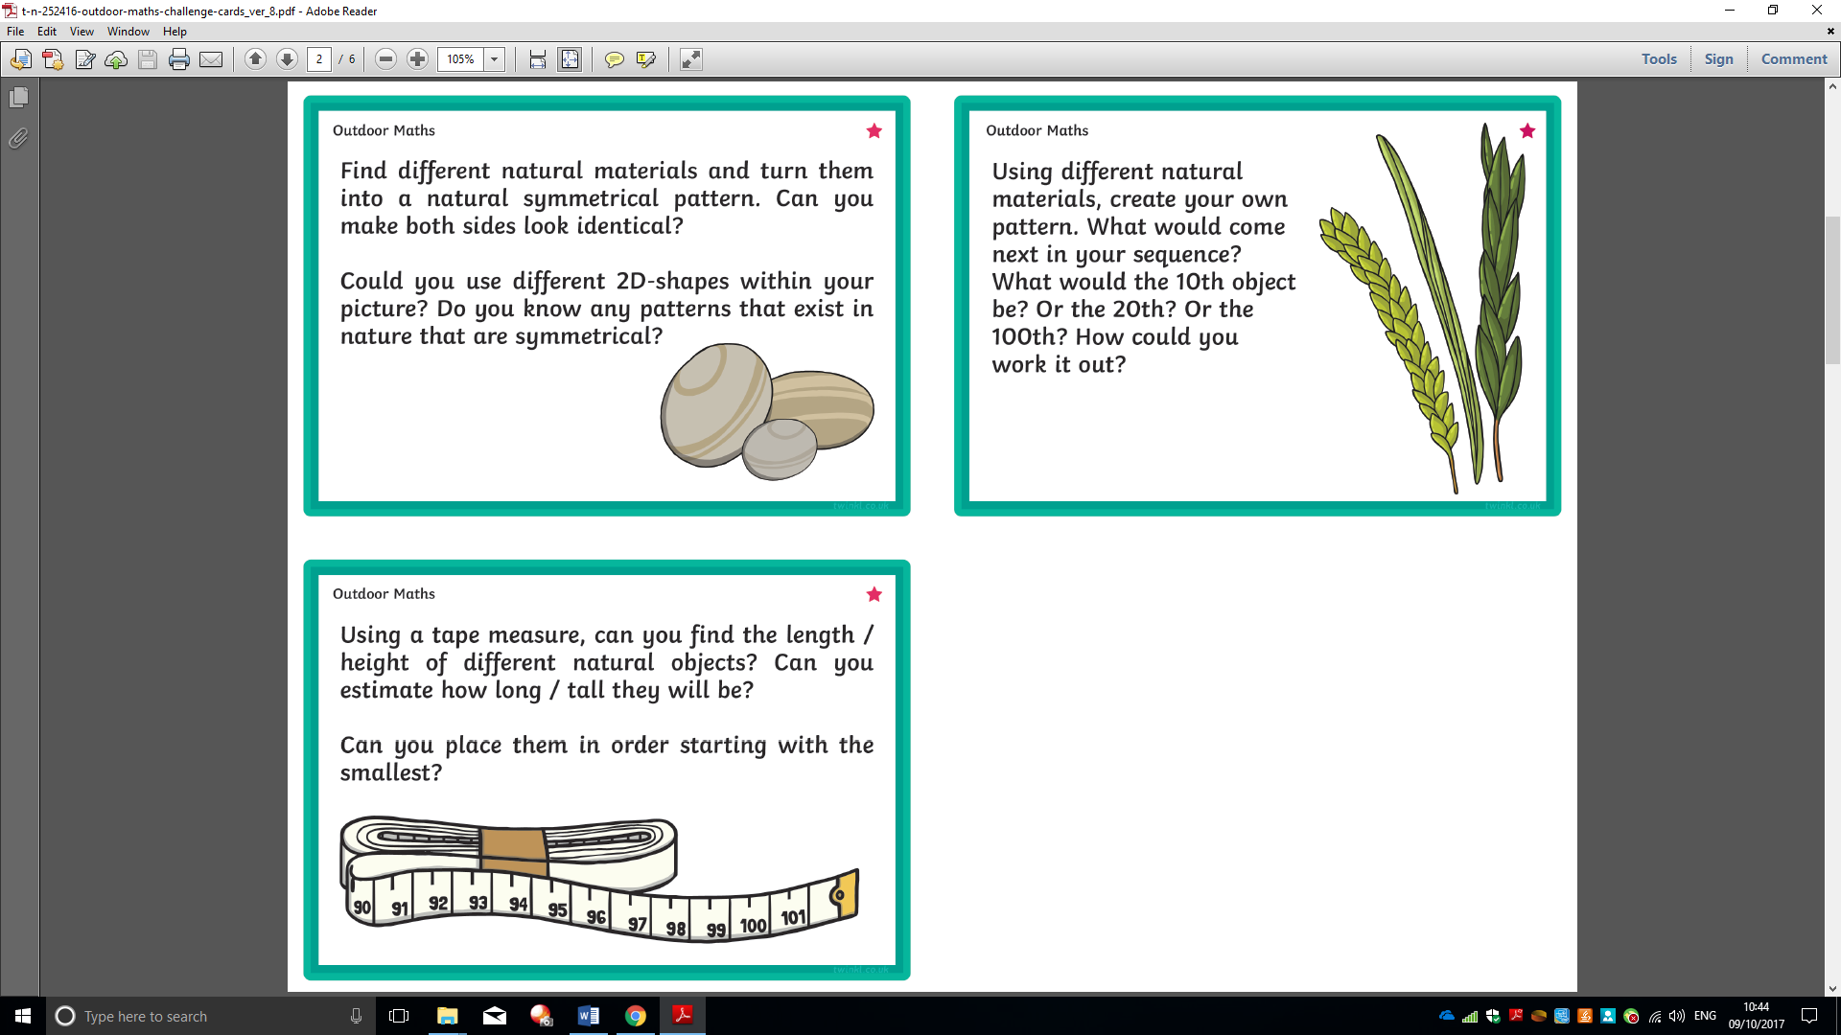

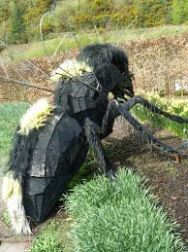

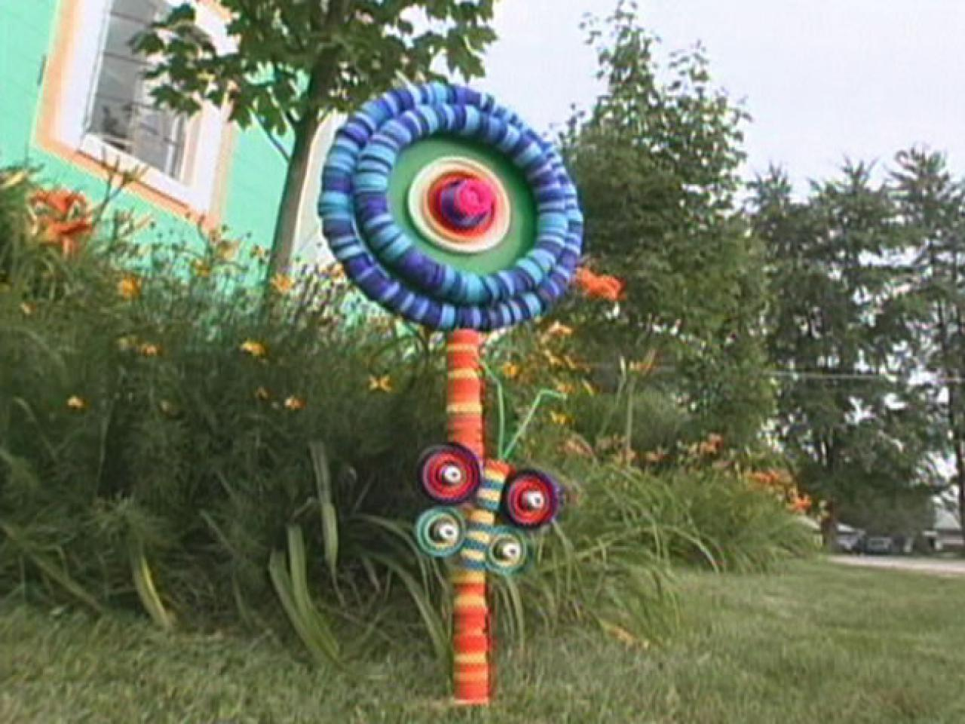

**Outdoor maths**

* Twinkl has lots of outdoor maths challenges (downloaded and in Outdoor adventure week)- <http://www.twinkl.co.uk/resource/t-n-252416-outdoor-maths-challenge-cards>
* Problems like (How many blades of grass in 10cm square of grass? How many in a meter? How many blades of grass on the whole field?)

**Science**

* Mini beasts – bug hunts and classification Nice resources on twinkle- <http://www.twinkl.co.uk/resource/t-t-5284-minibeast-sorting-activity>
* Classification of tree types or leaf types

**ICT**

* Research and create power points to show parents on learning focus e.g. mini beasts for cla

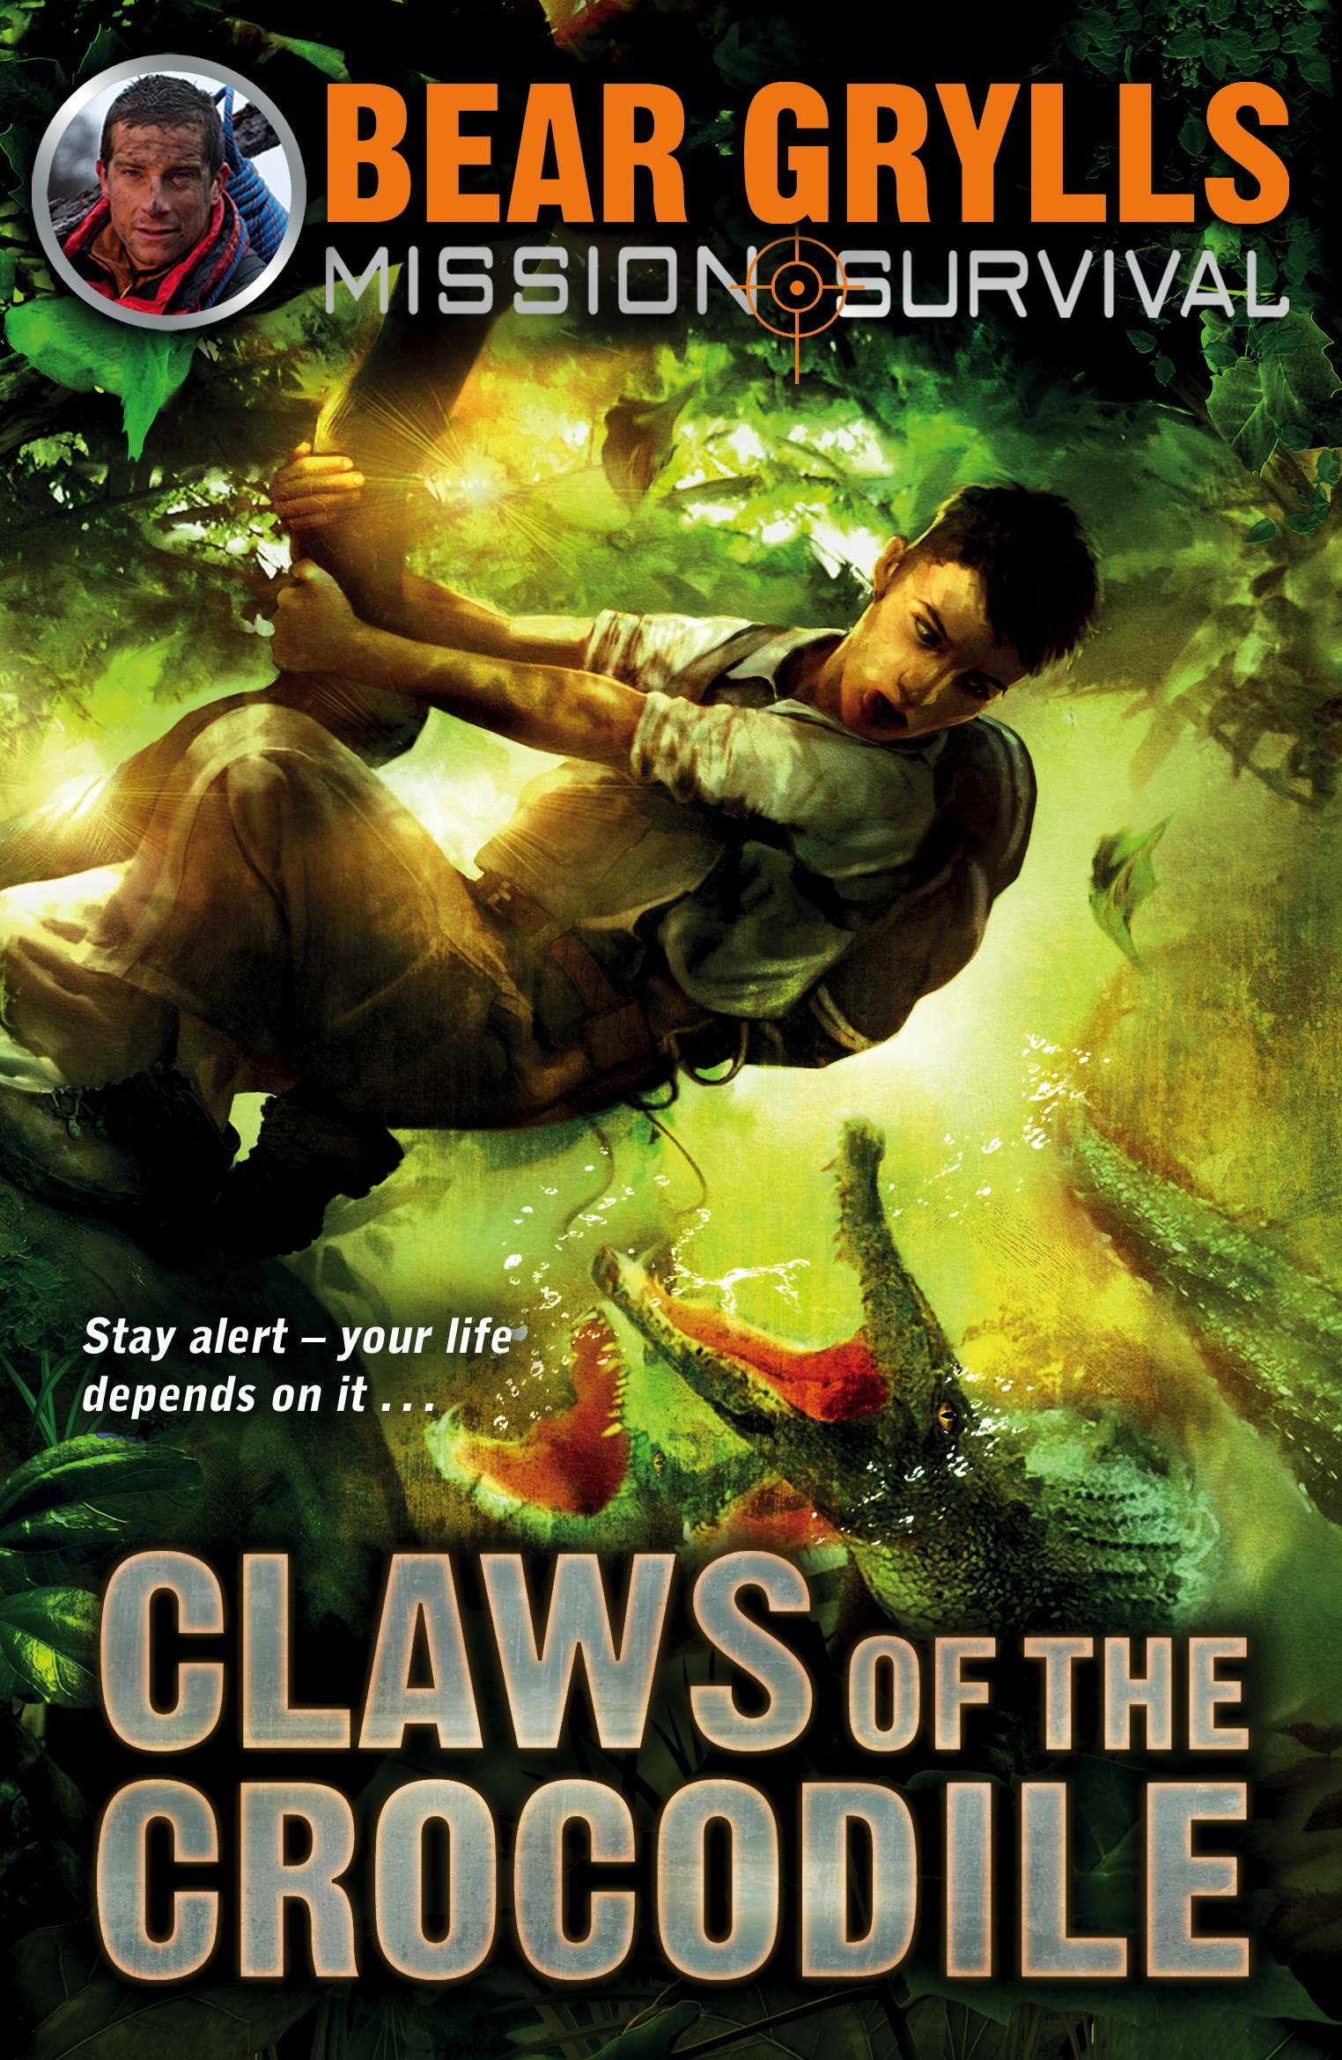

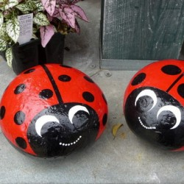

**Geography**

* Nature walk up and down the camel trail- link to a wide variety of focuses e.g. tree types