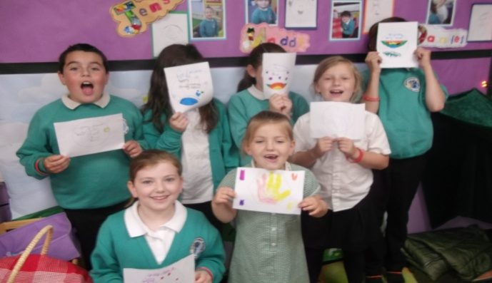

Contact Details

Any concerns/issues with regards to Young Carers contact Claire on 01208 74969 or psa@berrycoombe.cornwall.sch.uk

Our first meeting of Berrycoombe Young Carers was held on Tuesday 5th July 2016. The students spent time designing a logo for Berrycoombe Young Carers. We then voted for our favourite logo, which you can see above.

Date of 1st session

Tuesday 27th September 2016

12.45pm-1.15pm

In Smiley room

Who to contact

Schools Young Carer lead**- Claire Johnson** *Parent Support Advisor*

Young Carers Governor- **Debbie Mavriano**

Young Carer’s at Berrycoombe new logo

Hi Everyone

Since the last time I sent a newsletter we have had our first meeting. We used this time to think about all that they do to support at home. And what they would like to get out of the Young Carer’s sessions in school. As a group they decided that they would like to meet once a week at lunchtime, so from September we will be meeting every Tuesday lunch time 12.45pm-1.15pm. We will be doing activities together as a group as well as inviting in guests for example someone from Kernow Young Carers and other support professionals.

Kind Regards

Claire Johnson

Young Carers at Berrycoombe School

Issue 2

Sept 2016