**In Maths some children will be**

* Classifying, categorising and sorting dinosaurs.
* Measuring and comparing dinosurs to eveyday things

*‘Did you know a Brachiosaurus* is a little over 2 buses long!’

**Prepare to be amazed! As requested by the school council, Berrycoombe primary is about to have it’s biggest, wildest event week ever.**

**Get ready for dinosaur week coming 26th March**

**Below are some of the amazing dinotastic things the children will be doing**

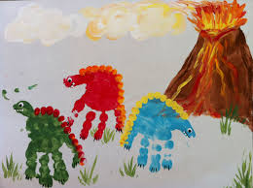Dinosaur hand prints

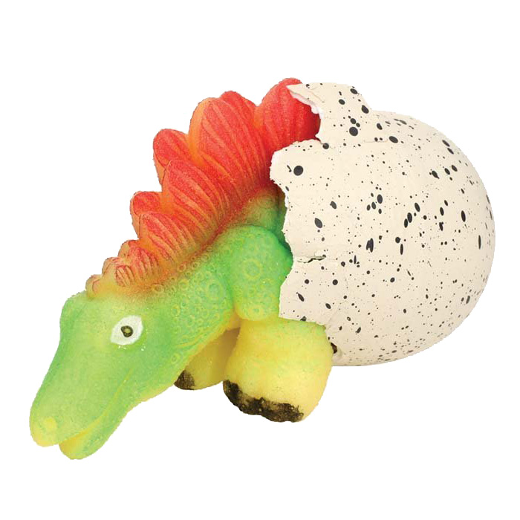

**In Art and DT children will be**

* Looking at famous dinosaur art
* Making dinosaur models or sculptures

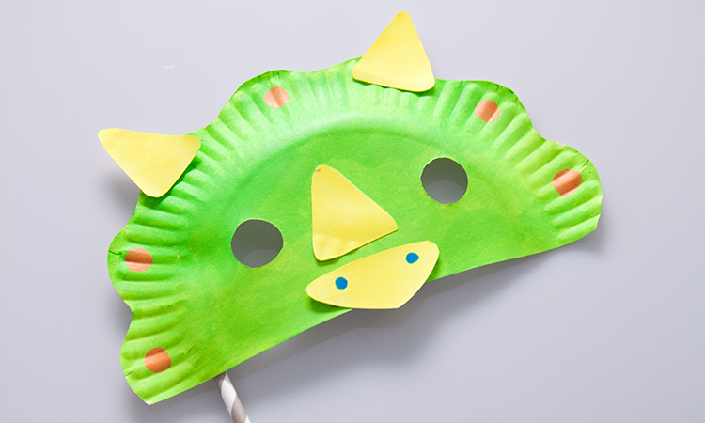Dinosaur masks

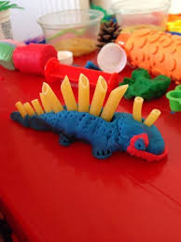Pasta and clay

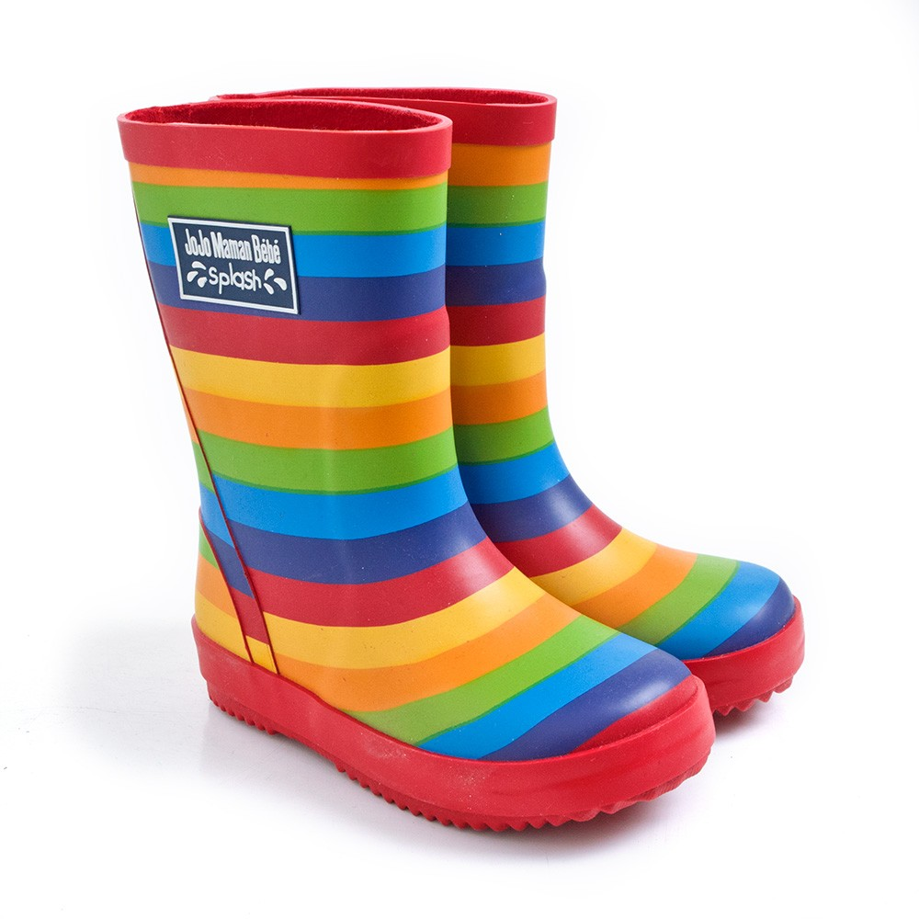

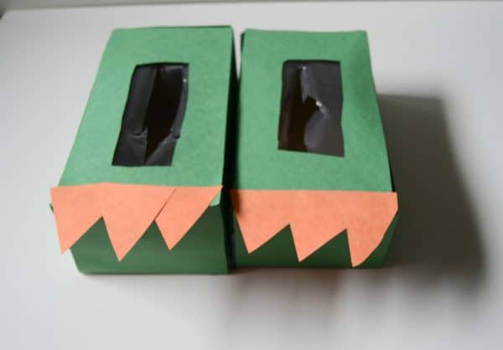

Tissue box dinosaur feet

**Dinosaur fancy Dress**

**Thursday**

Come as a dinosaur. *(Or non school uniform.)*

**Teachers will also be including ideas from our school council including-**

* Dinosaur cookies
* Describe a dinosaur (poems)
* Dinosaur dressing up
* Dinosaurs roaming the school
* Mini Dinosaur world (with volcanoes)
* Dinosaur Quiz

**Dinosaur Egg Hunt**

***Wednesday******before school on the field (bring your wellies)***

Come in wellies and hunt for chocolate dinosaur eggs



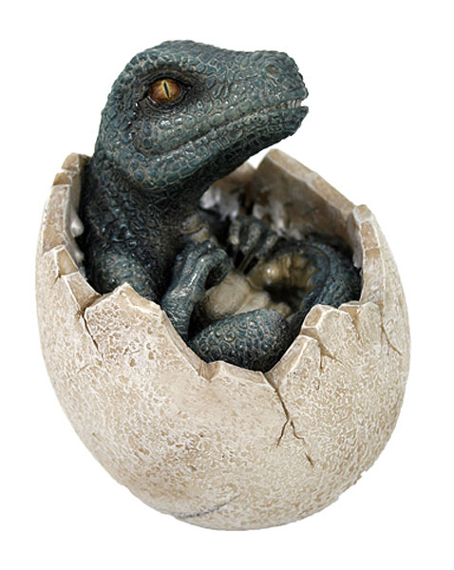

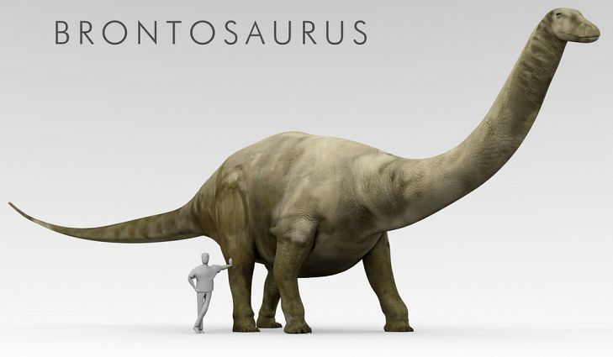

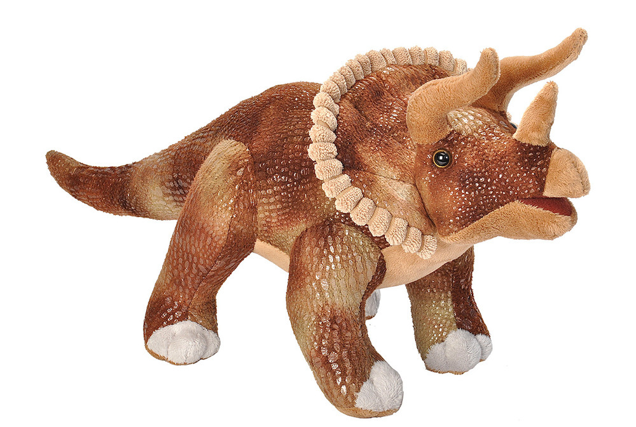

**In History some children will be**

* Learning dino facts
* Finding out what happened to the dinosaurs
* Learning about prehistoric times

**In Literacy some children will be**

* Reading dinosaur stories and creating their own versions.
* Creating and scripting a dinosaur **puppet** show
* Creating dinosaur Fact files
* Inventing silly Dinosaur names (Sammysaurus)

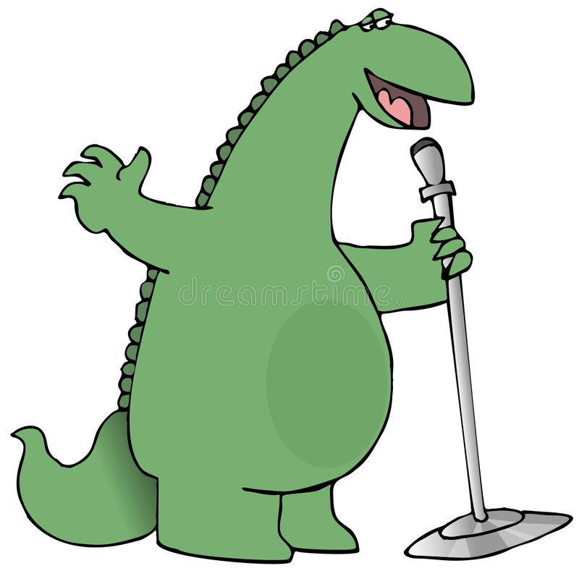

**In Music some children will be-**

Listening to famous music inspired by the world of dinosaurs.

**Monday Dinosaur workshops**

Prepare to be amazed. On Monday we have specialist dinosaur workshops with baby dinosaurs

|  |  |  |  |
| --- | --- | --- | --- |
| YR+Y1/R | Y1/2+Y2 | Y3+Y4 | Y5+Y6 |
| 9:15-10:00 | 10:00-11:00 | 11:00-11:50 | 1:30-2:30 |

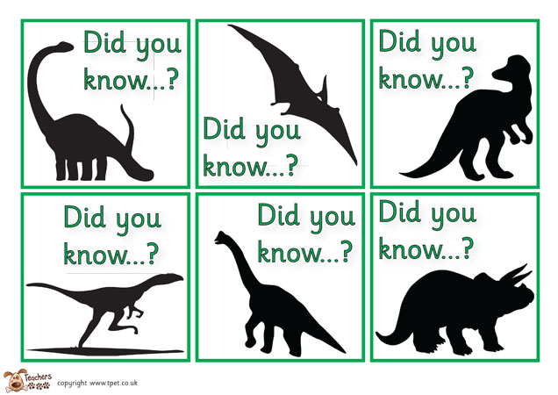

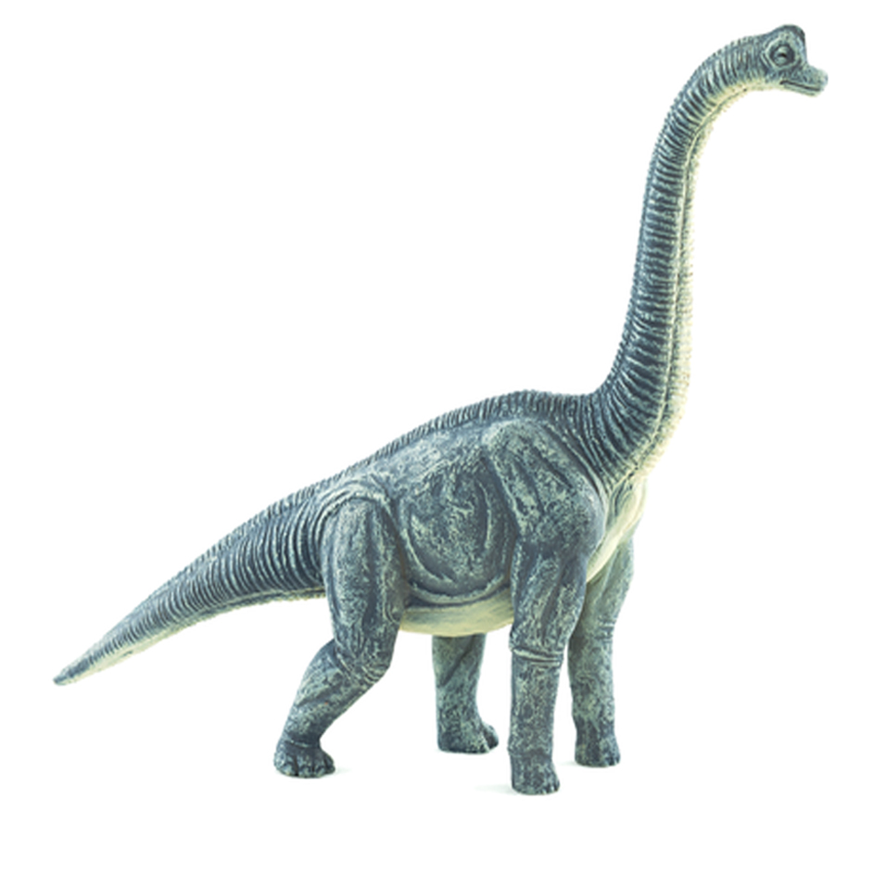



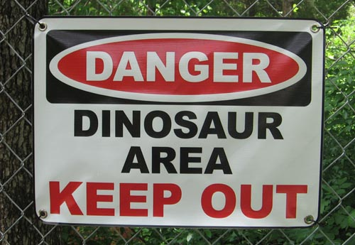

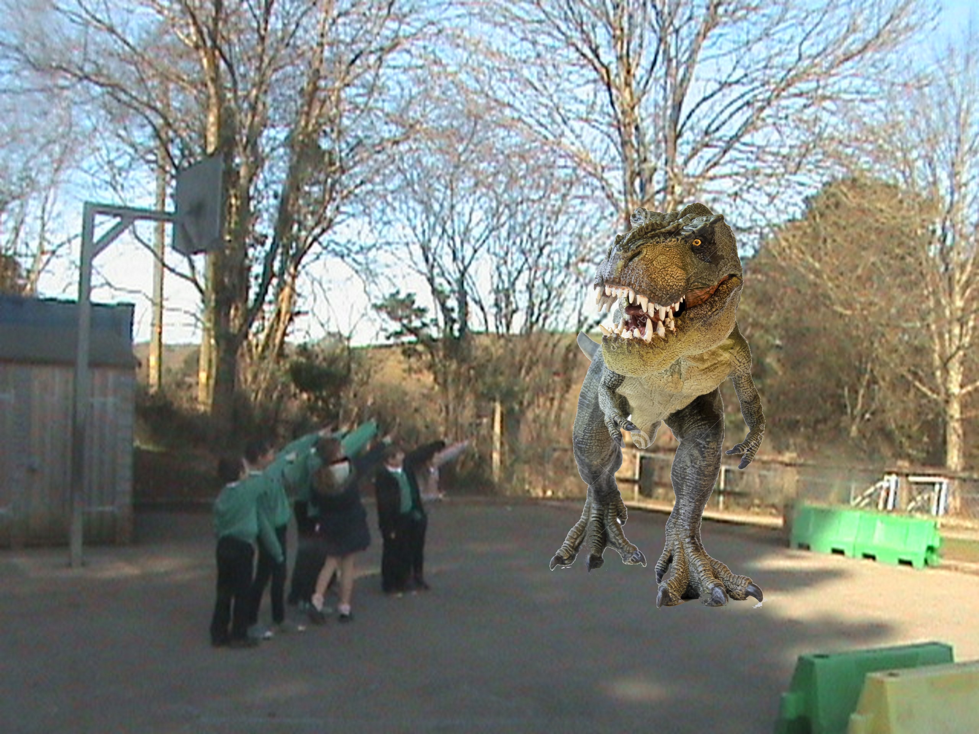

**Monday**

**IF YOU ARE ON THE PLAYGROUND AT 8:45 PLEASE BEWARE**

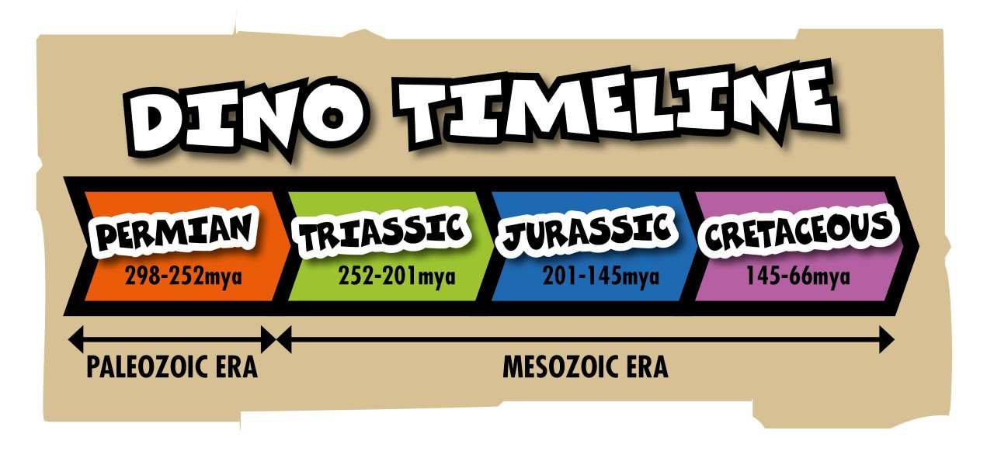

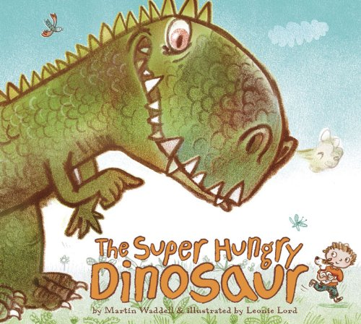

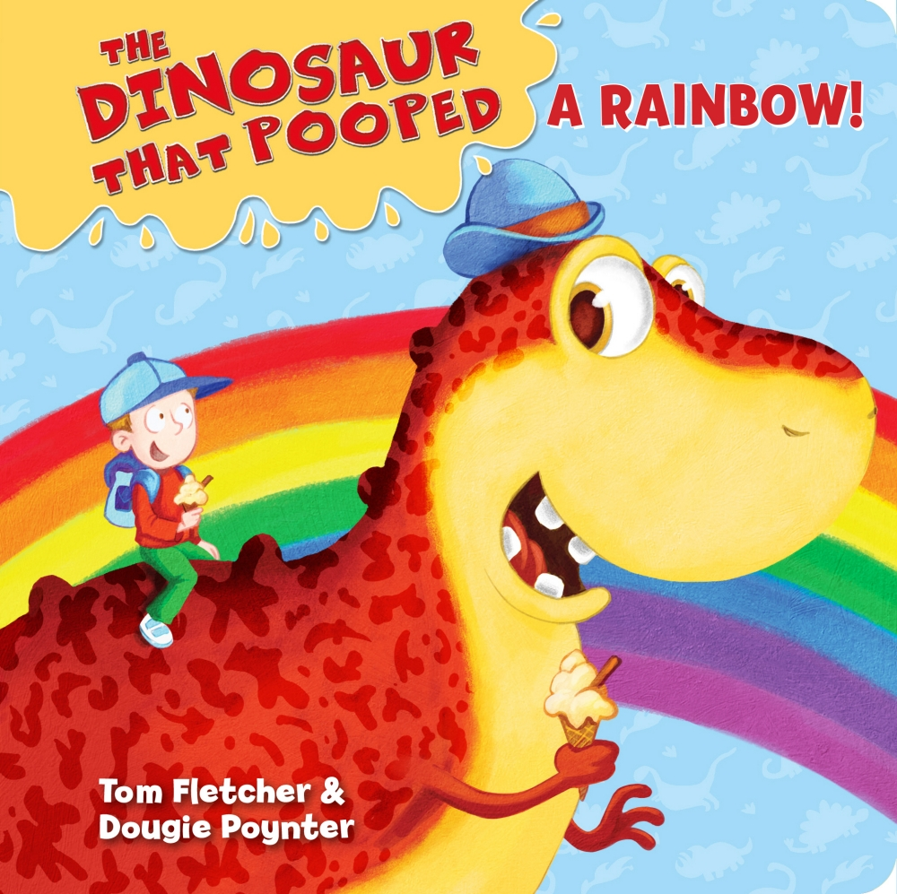

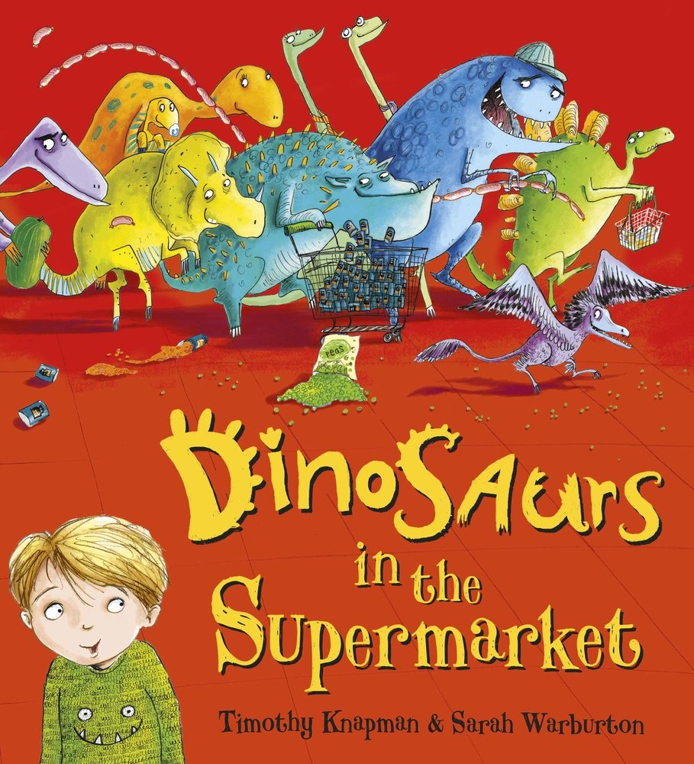

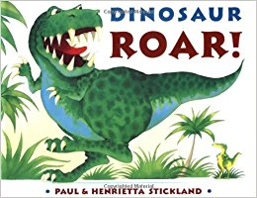

26th March 2018

**ROAR!**

**Dinosaur week**

