On the 5th of February the children of Berrycoombe will be unleashing their inner artists. When we asked the children what they would like for their next event week they were very clear-
‘We want to be creative and make stuff!’
The week will be crammed with creativity, art, painting and lots and lots of fun!
Each class will be focusing on a different artist learning about their life and their work. By the end of the week the children be experts at creating art in the style of their class artist.
Each class will have an art show and your teacher will let you know when you are invited to see all the wonderful art and learning that has taken place.
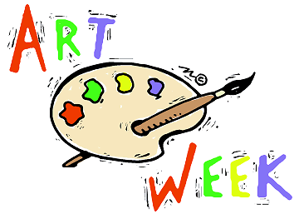
5th February 2018

Look out for your invitation to your child’s art show

The magical Authors Show
The children will also be taking part in the ‘magical authors show’. A live national lesson where they will take part in artistic activities linked to the works of illustration and writing.
The Giant Art Jigsaw Challenge
All the children will be creating a piece of a jigsaw in the style of their class artist. This will join together to make an enormous piece of art showcasing the children’s artistic talents and will be on display in the middle of the school
Year R  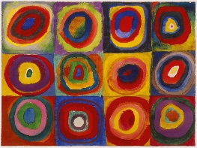  Reception will be learning about Kandinsky. They will be focusing on colour mixing and shape. | Year R/1  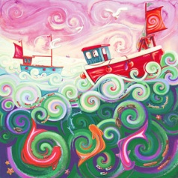  Reception Year 1 will be learning about Sara Holden. A local artist. They will be learning about her use of shape | Year 1-2  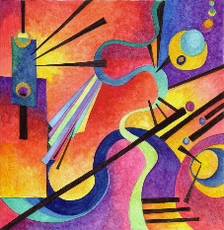  Year 1-2 will also be learning about Kandinsky. They will be focusing on colour mixing. | Year 2  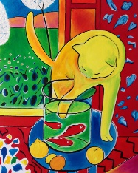  Year 2 will be learning about Matisse. They will be focusing on collage. | Year 3  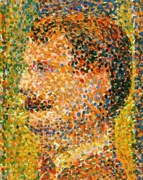  Year 3 will be learning about George Seurat. They will be learning about pointillism. | Year 4  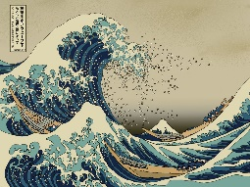  Year 4 will be learning about Hokusai. They will using his style to paint famous landmarks around Bodmin. | Year 5  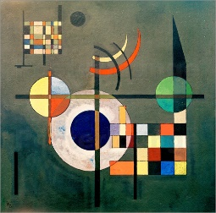  Year 5 will be learning about Kandinsky. They will be focusing on how to express feelings and emotions in art. | Year 6  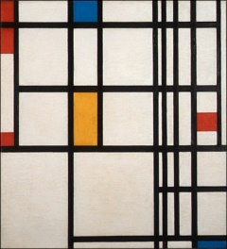  Year 6 will be learning about Mondrian. They will be looking at how to make realistic images more abstract.

Is your child eligible for Free School Meals?

Your child may be eligible for free school meals if you (or the child themselves in their own right) is in receipt of any of the following benefits.

Income Support (IS)
Job Seekers' Allowance (Income-Based) and equal based Job Seekers Allowance.
Income Related Employment and Support Allowance (ESA-IR) and equal based Employment and Support Allowance.
Child Tax Credit (CTC) with an Annual income of less than £16,190.
Guarantee Element of Pension Credit (GPC)
Immigration and Asylum Act 1999 (IAA) Support
Universal Credit
Please note that anyone claiming Working Tax Credit, Contribution-Based Job Seeker's Allowance and/or Contribution-Based Employment and Support Allowance is NOT eligible for free school meals, regardless of what other benefits/credits are being claimed. However, you will be temporarily eligible to claim free school meals if you receive a Working Tax Credit run-on, which is the payment someone may receive for a further four weeks after they stop qualifying for Working Tax Credit.
Even if your child is in years R, R/1, 1/2 and 2 it is important that you still apply for free school meals as this helps the school fund more intervention groups to support the children’s learning.

You can apply online or please call at the office if you require any support with the form!

